Geography of the United Kingdom

General information about UK

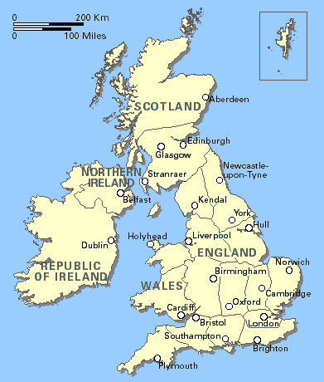
The United Kingdom of Great Britain and Northern Ireland (usually shortened to the United Kingdom, the UK, or Britain) is a country and sovereign state that is situated in west Northern Europe. Its territory and population are primarily situated on the island of Great Britain and in Northern Ireland on the island of Ireland, as well as numerous smaller islands in the surrounding seas. The United Kingdom is bounded by the Atlantic Ocean, and its ancillary bodies of water, including the North Sea, the English Channel, the Celtic Sea, and the Irish Sea. The mainland is linked to France by the Channel Tunnel and Northern Ireland shares a land border with the Republic of Ireland.

The United Kingdom is a political union made up of four constituent countries: England, Scotland, Wales and Northern Ireland. The United Kingdom also has several overseas territories, including Bermuda, Gibraltar, Montserrat and Saint Helena among others. The dependencies of the Channel Islands and the Isle of Man, formally possessions of the Crown, form a federacy with the United Kingdom collectively known as the British Islands. A constitutional monarchy, the United Kingdom is a Commonwealth Realm, sharing the same person — Queen Elizabeth II — with the fifteen other Realms as monarch and head of state, forming a personal union with each.

A member of the G8, the United Kingdom is a highly developed country with the fifth largest economy in the world and second largest in Europe, estimated at US$2.2 trillion. It is the third most populous state in the European Union with a population of 60.2 million and is a founding member of the North Atlantic Treaty Organisation (NATO) and the United Nations (UN), where it holds a permanent seat on the Security Council. The UK is also one of the world's major nuclear powers.

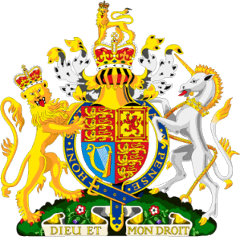
The Royal Coat of Arms of the United Kingdom is the official coat of arms of the British monarch, currently Queen Elizabeth II. These arms are used by the Queen in her official capacity as monarch, and are officially known as her Arms of Dominion.

The shield is quartered, depicting in the first and fourth quarters the three lions passant guardant of England; in the second, the rampant lion and double tressure fleury-counter-fleury of Scotland; and in the third, a harp for Ireland. The crest is a lion statant guardant wearing the imperial crown, itself on another representation of that crown.

The dexter supporter is a likewise crowned lion, symbolizing England; the sinister, a unicorn, symbolising Scotland. According to legend a free unicorn was considered a very dangerous beast; therefore the British heraldic unicorn is chained.

The coat features both the motto of British monarchs Dieu et mon droit (God and my right) and the motto of the Order of the Garter, Honi soit qui mal y pense (Shamed be he who thinks ill of it) on a representation of the Garter behind the shield.

Symbols of UK


* The flag of the United Kingdom is the Union Flag (commonly known as the "Union Jack", though this is technically only correct when at sea). Created from the superimposition of the flags of England (St George's Cross) and Scotland (Saint Andrew's Cross); the Saint Patrick's cross, representing Ireland, was added to this in 1801.

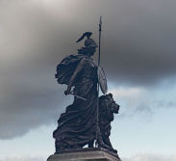
* Britannia is a personification of the UK, originating from the Roman occupation of southern and central Great Britain. Britannia is symbolised as a young woman with brown or golden hair, wearing a Corinthian helmet and white robes. She holds Poseidon's three-pronged trident and a shield, bearing the Union Flag. Sometimes she is depicted as riding the back of a lion. In modern usage, Britannia is often associated with maritime dominance, as in the patriotic song Rule Britannia.

The Statue of Britannia in Plymouth

* The national anthem of the UK is God Save the Queen.

* The bulldog is sometimes used as a symbol of Great Britain.

* Britain (especially England) is also personified as the character John Bull.

* The ancient British landscape, and especially some of its distinctive fauna such as the oak tree and the rose, has long been a widely-used proxy for the visual representation of British identity.

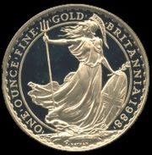
* The lion has also been used as a symbol of the UK; one is depicted behind Britannia on the 50 pence piece and one is shown crowned on the back of the 10 pence piece, it is also used as a symbol on the non-ceremonial flag of the British Army. Lions have been used as heraldic devices many times, including in the royal arms of both the kingdoms of England, Scotland and Kingdom of Gwynedd in Wales. The lion is featured on the emblem of the England national football team, giving rise to the popular football anthem Three Lions.

Britannia, featured on Royal Mint gold bullion coin

Physical Geography of the United Kingdom

The United Kingdom of Great Britain and Northern Ireland, or UK, is in Western Europe. It comprises the island of Great Britain (England, Scotland and Wales) and the northeastern one-sixth of the island of Ireland (Northern Ireland), together with many smaller islands.

The mainland areas lie between latitudes 49°N and 59°N (the Shetland Islands reach to nearly 61°N), and longitudes 8°W to 2°E. The Royal Greenwich Observatory, near London, is the defining point of the Prime Meridian. The United Kingdom has a total area of 245,888 km².

The UK lies between the North Atlantic Ocean and the North Sea, and comes within 35 km (22 miles) of the northwest coast of France, from which it is separated by the English Channel. Northern Ireland shares a 360 km international land boundary with the Republic of Ireland. The Channel Tunnel ("Chunnel") bored beneath the English Channel, now links the UK with France.

Most of England consists of rolling lowland terrain, divided east from west by more mountainous terrain in the Northwest (Cumbrian Mountains of the Lake District) and north (the upland moors of the Pennines) and limestone hills of the Peak District by the Tees-Exe line. The lower limestone hills of the Isle of Purbeck, Cotswolds, Lincolnshire Wolds and chalk down of the Southern England Chalk Formation. The main rivers and estuaries are the Thames, Severn and the Humber Estuary. The largest urban area is Greater London. Near Dover, the Channel Tunnel links the United Kingdom with France. There is no peak in England that is 1,000 metres (3,300 ft) or greater, the highest mountain being Scafell Pike in England's Lake District, at some 978 metres (3,208 ft).

Scotland's geography is varied, with lowlands in the south and east and highlands in the north and west, including Ben Nevis, the highest mountain in the British Isles at 1,343 metres (4,406 ft). There are many long and deep-sea arms, firths, and lochs. Scotland has nearly 800 islands, mainly west and north of the mainland, notably the Hebrides, Orkney Islands and Shetland Islands. The capital city is Edinburgh, the centre of which is a World Heritage Site. The largest city is Glasgow. In total it is estimated that the UK includes around 1,000 islands, with 700 in Scotland alone.

Wales (Cymru in Welsh) is mostly mountainous, the highest peak being Snowdon (Yr Wyddfa) at 1,085 metres (3,560 ft) above sea level. North of the mainland is the island of Anglesey (Ynys Môn). The largest and capital city is Cardiff (Caerdydd); it has been the Welsh Capital city since 1955, located in South Wales. The greatest concentration of people lives in the south, in the cities of Swansea and Newport, as well as Cardiff, and the South Wales Valleys. The largest town in North Wales is Wrexham.

Northern Ireland, making up the north-eastern part of Ireland, is mostly hilly. The capital is Belfast ('Béal Feirste' in Irish), with other major cities being Derry ('Doire' in Irish) and Armagh. The province is home to one of the UK’s World Heritage Sites, the Giant's Causeway, which consists of more than 40,000 six-sided basalt columns up to 40 feet (12 m) high. Lough Neagh, the largest body of water in the British Isles, by surface area (388 km² / 150 mi²), can be found in Northern Ireland. The highest peak is Slieve Donard at 849 metres (2,786 ft) in the province's Mourne Mountains.

Mountains and hills

At 1,344 metres, Ben Nevis is the highest peak in the UK. The ten tallest mountains in the UK are all found in Scotland. The lowest point of the UK is in the Fens of East Anglia, in England, parts of which lie up to 4 m below sea level.

The highest peaks in each part of the UK are:
Scotland: Ben Nevis (Nevis Range, 1,344 m)
Wales: Snowdon (Cambrian Mountains, 1,085 m)
England: Scafell Pike (Cumbrian Mountains, 977 m)
Northern Ireland: Slieve Donard (Mourne Mountains, 852 m)

The ranges of mountains and hills in the UK include:
Scotland: Cairngorms, Cheviot Hills, Scottish Highlands, Southern Uplands, Grampian Mountains
Wales: Brecon Beacons, Cambrian Mountains, Snowdonia, Black Mountains, Preseli Hills
England: Chilterns, Cotswolds, Dartmoor, Exmoor, Lake District, Malvern Hills, Mendip Hills, North Downs, Peak District, Pennines, Salisbury Plain, South Downs, Shropshire Hills
Northern Ireland: Mountains of Mourne, Antrim Plateau, Sperrin Mountains

Rivers and lakes

The longest river in the UK is the River Severn (220 miles, 354 km) which flows through both Wales and England. The deepest lake in the UK is Loch Morar with a maximum depth of 309 metres (Loch Ness is second at 228 metres deep). The deepest lake in England is Wastwater which descends to 79 metres (258 feet).

The longest rivers in the UK are:
England: River Thames (215 miles, 346 km)
Scotland: River Tay (117 miles, 188 km)
N. Ireland: River Bann (76 miles, 122 km)
Wales: River Tywi (64 miles, 103 km)

The largest lakes in the UK are:
N. Ireland: Lough Neagh (147.39 sq mi, 381.74 km²)
Scotland: Loch Lomond (27.46 sq mi, 71.12 km²)
England: Windermere (5.69 sq mi, 14.74 km²)
Wales: Lake Vyrnwy (3.18 sq mi, 8.24 km²)

Artificial waterways

As a result of its industrial history, the United Kingdom has an extensive system of canals, mostly built in the early years of the Industrial Revolution, before the rise of competition from the railways. The United Kingdom also has numerous dams and reservoirs to store water for drinking and industry. The generation of hydroelectric power is rather limited, supplying less than 2% of British electricity mainly from the Scottish Highlands.

A reservoir is, most broadly, anything used for storage of large amounts of a liquid, which can be put into and drawn from the reservoir. It is in essence a buffer. Most often, a reservoir refers to an artificial lake, used to store water for various uses. They are created first by building a sturdy dam, usually out of cement, earth, rock, or a mixture of all three. Once the dam is completed, a stream is allowed to flow behind it and eventually fill it to capacity.
Coastline

The UK has a coastline which measures approximately 12,429 km (although this is a somewhat arbitrary figure since, being a fractal, the length of the coastline will increase as the unit with which is it measured decreases). The heavy indentation of the coastline helps to ensure that no location is more than 125 km from tidal waters.

The UK claims jurisdiction over the continental shelf, as defined in continental shelf orders or in accordance with agreed upon boundaries, an exclusive fishing zone of 200 n. miles (370 km), and territorial sea of 12 n. miles (22 km). Some parts of the British coast are subject to rapid erosion, including Holderness (in the East Riding of Yorkshire), Norfolk and Suffolk.

Inlets: Cardigan Bay, Lyme Bay, Bristol Channel, Thames estuary, Morecambe Bay, The Wash, Humber estuary, Firth of Forth, Firth of Tay, Moray Firth.

In total, it is estimated that the UK is made up of over 1000 small islands, some being natural and some being man-made crannogs, which were built in past times using stone and wood and which were enlarged by natural waste building up over time.

Islands of England: Islands of Scotland:
Lundy Orkney Islands
Isles of Scilly Shetland Islands
Isle of Wight Inner Hebrides
Farne Islands Outer Hebrides
Lindisfarne Rockall
Isle of Portland Bass Rock
Fair Isle

Islands of Wales: Islands of Northern Ireland:
Anglesey Rathlin Island
Skomer Island
Skokholm Island
Ramsey Island
Bardsey Island
Holy Island

The geology of the UK is such that there are many headlands along its coast, here are some of the most notable ones:

* Cornwall / Lands End, The Lizard, Cape Cornwall
* Cumbria / Furness
* Devon / Start Point, Berry Head, Hartland Point
* Dorset / Old Harry Rocks, St Alban's Head, Portland Bill
* East Sussex / Beachy Head
* Kent / North Foreland
* Sutherland / Cape Wrath
* Swansea /Gover Peninsula
* Wigtownshire /Rhins of Galloway
* Yorkshire /Flamborough Head

Climate

The current climate of the United Kingdom is classified as temperate, with warm summers, cool winters and plentiful precipitation throughout the year. The principle factors of influence on the climate include the UK's northerly latitude (which ranges from 50° to 60° N), its close proximity to the Atlantic Ocean and, especially, the warming of the waters around the British Isles by the Gulf Stream. The weather can be notoriously changeable from one day to the next but temperature variations throughout the year are relatively small.

The climate of the United Kingdom is significantly influenced by the maritime tropical, maritime polar, continental polar and continental tropical air masses. The UK is at the boundary of convergence between the warm tropical air to the south and the cold polar air to the north. In this area, the large temperature variation creates instability and this major factor that influences the notoriously changeable and often unsettled weather the UK experiences, where many or all types of weather can be experienced in a single day.

Average annual rainfall varies from over 3,000 mm (120 inches) in the Scottish Highlands down to 553 mm (21.8 in) in Cambridge. The county of Essex is one of the driest in the UK, with an average annual rainfall of around 600 mm (24 inches), although it typically rains on over 100 days per year. In some years rainfall in Essex can be below 450 mm (18 inches), less than the average annual rainfall in Jerusalem and Beirut.

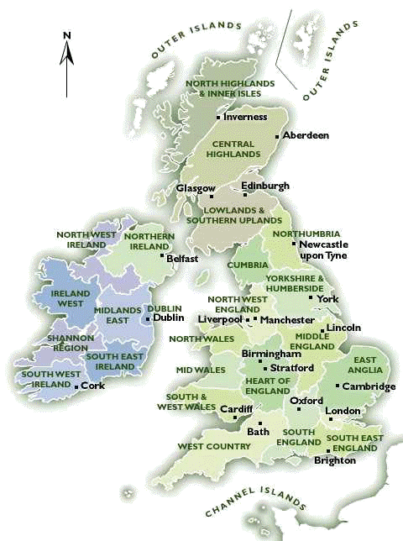
The highest temperature recorded in the UK was 38.5 °C at Brogdale, near Faversham, in the county of Kent, on August 10, 2003. The lowest was -27.2 °C recorded at Braemar in the Grampian Mountains, Scotland, on February 11, 1895 and January 10, 1982 and Altnaharra, also in Scotland, on December 30, 1995.

Fauna and flora

With its mild climate and varied soils, the United Kingdom has a diverse pattern of natural vegetation. Over the centuries, much of the forest area, especially on the lowlands, was cleared for cultivation. Today only about 9% of the total surface is wooded. Fairly extensive forests remain in east and north Scotland and in southeast England. Oak, elm, ash, and beech are the most common trees in England. Pine and birch are most common in Scotland. Almost all the lowland outside the industrial centers is farmland, with a varied seminatural vegetation of grasses and flowering plants. Wild vegetation consists of the natural flora of woods, fens and marshes, cliffs, chalk downs, and mountain slopes, the most widespread being the heather, grasses, gorse, and bracken of the moorlands.

The fauna is similar to that of northwestern continental Europe, although there are fewer species. Some of the larger mammals—wolf, bear, boar, and reindeer—are extinct, but red and roe deer are protected for sport. Common smaller mammals are foxes, hares, hedgehogs, rabbits, weasels, stoats, shrews, rats, and mice; otters are found in many rivers, and seals frequently appear along the coast. There are few reptiles and amphibians. Roughly 230 species of birds reside in the United Kingdom, and another 200 are migratory. Most numerous are the chaffinch, blackbird, sparrow, and starling. The number of large birds is declining, however, except for game birds—pheasant, partridge, and red grouse—which are protected. With the reclamation of the marshlands, waterfowl are moving to the many bird sanctuaries. The rivers and lakes abound in salmon, trout, perch, pike, roach, dace, and grayling. There are more than 21,000 species of insects.

Economic Geography of the United Kingdom

The Industry

The industry of GB has developed on the basis of rich coal and iron fields. Nowadays the situation has changed and GB has to import most of the row materials. Black coal fields cover 7% of the total area of GB. The main coal fields are Clyde, Cumberland (Western England), Northumberland (Northern England), Lancashire, Yorkshire, Midlands, Wales and Bristol. Iron is of poorer quality, but there are small fields in Scotland. Other minerals as cooper, lead, zinc and tin are mined on a small scale in the western parts of GB. Rich oil fields were discovered in the North Sea in 1970s.

GB is highly industrial country. Most important is shipbuilding and engines. Great tradition has the textile industry which is based on English wool and imported raw cotton. The centres of cotton industry are in Lancaster – Manchester. New kind of industry is the chemical industry with centres in London, Newcastle and Glasgow but also electronics, automobile and aeroplane industries have been developed mainly in the Midlands.

An important place in the industry of GB has the sea. Fishing has always been important branch of industry, especially in the east, where the great fishing ports of Grimsby, Hull and Great Yarmouth are situated.

The other natural resources are:
petroleum, natural gas, limestone, chalk, gypsum, silica, rock salt, china clay, iron ore, tin, silver, gold, lead.

Agriculture

Britain is one of the most mechanized countries in the world. About 48 million acres is used in agriculture. There is a half million people working on the land. About 25% of all employees are in the 70 largest enterprises, each employing several thousands of people. Many companies are based in GB but there are foreign-owned like Esso, Petroleum, Ford, and American Tobacco. Basic industries deal with coal, iron and steel. Public utilities are gas, electricity, railways, canal and air transport. Also we know that Britain can cover own needs in milk, potatoes, poultry and vegetables.

County distribution

- London – electronics, foodstuff, furniture, precision instruments, consumer goods, motorcars, aircrafts
- West and South West England /Bristol, Southampton, Plymouth/ – aircraft, paper paint industry, shipyards, ports, woollen worsted cloth, naval dock-yards (lodenice)
- The Midlands /Birmingham, Coventry, Wolverhampton/ - manufacture of metals, electronic and engineering products, pottery (hrnčiarstvo) and china manufacture, motor vehicles, coal mining (ťažba uhlia)
- Lancashire /Manchester, Sheffield, Liverpool/ – cotton and synthetic fibre industry, sugar
- North East England /Newcastle/ – coal industry
- East England and Lincolnshire – agricultural machinery, food canning (konzervovanie), fish industry
- Yorkshire /Leeds, Sheffield/ - textile/wool, steel, cuttery
- Wales – coal minning, chemical, synthetic fibres, plastics, electronics, oil-refining

Industrial Distribution

Coal mining: Midlands, Yorkshire, Newcastle, Wales, and Glasgow
Ship-building: London, Liverpool, Tyneside, Plymouth, Glasgow
Light – engineering: Manchester, Birmingham
Chemical: Leeds, London. Tyneside
Food: East England
Footwear: Manchester, Leeds, Noewich
Electronics: London, Midlends
Textile: Yorkshire, Manchester

London

London is the capital city of England and the United Kingdom - coming from Roman Londinium. An important settlement for around two millennia, London is today one of the world's most important business and financial centres, and its involvement in politics, culture, education, entertainment, media, fashion, sport and the arts all contribute to its status as one of the key global cities.

London is the most populous city in the European Union. Its population is very cosmopolitan, drawing from a diverse range of peoples, cultures and religions, speaking over 300 different languages. Residents of London are referred to as Londoners. London is an international transport hub, with five international airports and a large port. It serves as the largest aviation hub in the world, and its principal airport, Heathrow, carries more international passengers than any other.

London is a major tourist destination - counting iconic landmarks such as the Houses of Parliament, Tower Bridge, the Tower of London, Westminster Abbey, Buckingham Palace and the London Eye amongst its many attractions, along with famous institutions such as the British Museum and the National Gallery. Samuel Johnson remarked that "When a man is tired of London, he is tired of life".

